**How to change the Multi-Factor Authentication (MFA) notification method**

The City of Niles has recently implemented MFA to help secure our network infrastructure. A two-step verification process is now required to access the email system. This is accomplished by having our users provide a user name and password followed by and second method of user verification. The default second method of user verification is to have Microsoft send a text message to your cell phone.

Please follow the steps below If you would like to have Microsoft alert you by calling on your desk phone or home rather than sending a text message to your personal cell phone.

There are slightly different settings you will select based on whether you have a nilesmi.org or nilemi.net email address. These are detailed below.

Open a web browser and navigate to <https://www.office.com>

Click your account name located in the upper right corner, then select **My Account**.

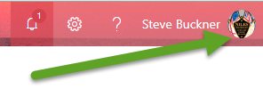 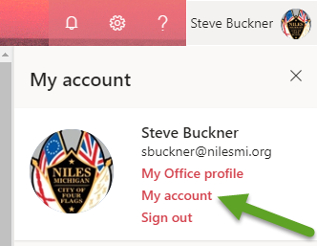

Click **Manage security & privacy**, the select **Add or change security verification settings**.

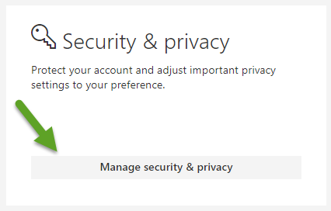 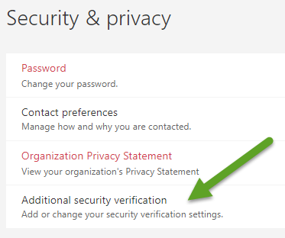

Once in the Security & privacy section click **Update your phone numbers for account security.**

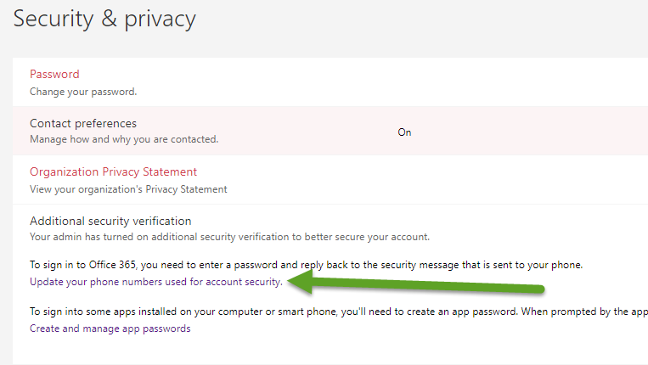

From the drop down select **Call my office phone.**

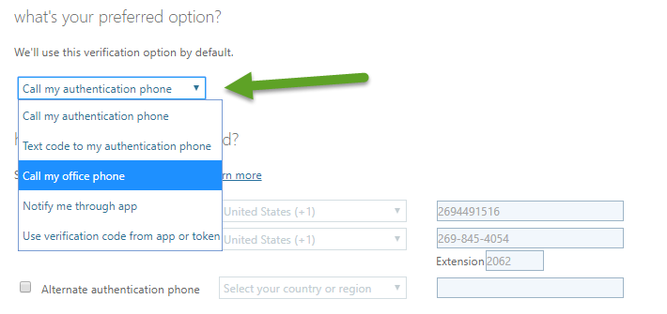

For users with a **Nilesmi.org** email address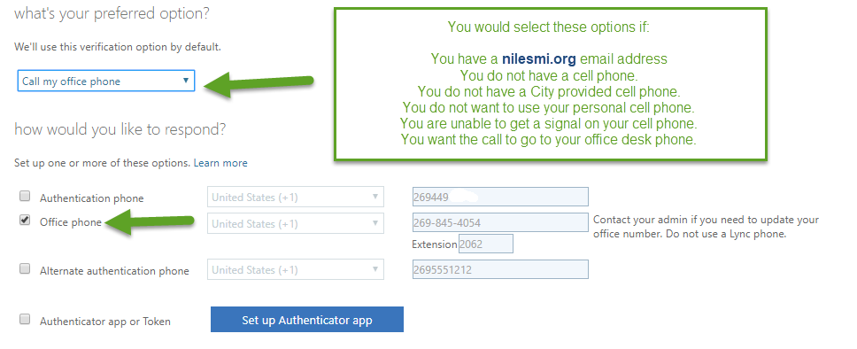

For users with a **Nilesmi.net** email address

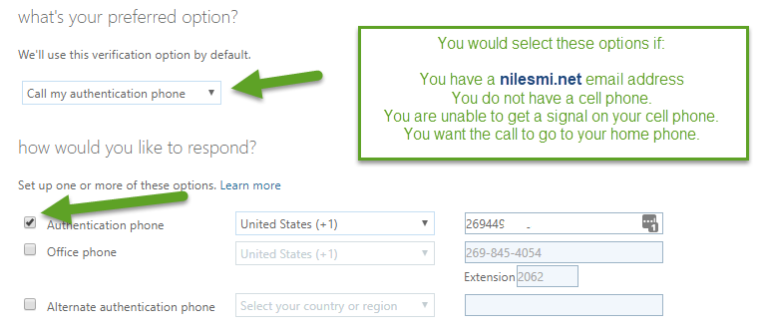

Click save.

You should receive a call from Microsoft the next time that you are required to verify your account. Follow the instruction provided by the automated attendant. You will most likely be prompted to press **#** once or twice.

